January 2025 Newsletter
Happy New Year!!


Committee: Peter Humphreys (Chair), Peter Catton (Treasurer), Janos Tomics (member) Lindsay Nugent (member) Ernest Bow (web site and social media member)
Contact: baatingroup@outlook.com Tel. 01256 780412
web https://www.basingstoketinnitusgroup.org
Affiliated to Tinnitus UK: TUK Free Phone 0800 0180527 web https://www.tinnitus.org.uk/
Members of Basingstoke Voluntary Action: Web https://www.bvaction.org.uk/

Welcome to our forty first newsletter. We hope you all had a great Christmas time. We hope you are all well and are managing your T. ok. Our Group’s fourth birthday is next month and then we are into our fifth year of successful running. Our meeting dates for 2025 are listed at the end of this newsletter. Our January zoom meeting includes our important Annual General Meeting (see details in this newsletter). Do please attend.

Next meeting: 15 January 2025, ‘Share and Care’ on Zoom plus a brief Annual General Meeting
We will start the session with a brief AGM. This is a bureaucratic requirement for a small, unregistered charity like us following Charity Commission guidelines.
The Basingstoke Tinnitus Support Group is owned and managed by its members. The governing body is the Annual General Meeting (AGM) or other General Meeting as may be held in accordance with its constitution. The role of the AGM is to elect a Chair and Officers and Members of a Management Committee who are responsible managing the Group throughout the year. The Committee’s responsibilities include approving the Annual Report and Accounts.
The Committee in the December newsletter invited people to self-nominate to join our existing committee of five. Unfortunately, at the time of writing this we have had no new nominations.
The Agenda for the meeting and Annual Report and Accounts will be published shortly and hopefully in week commencing 5 January 2025.

For newer members, a ‘Share and Care' meeting is when members update on where they are on tinnitus and newer members, if they want to, have the opportunity to describe their own tinnitus journey and anything they have found that mitigates the effect of their tinnitus. These meetings are for members only, are entirely confidential, with no recording or detailed notes taken. An email with the zoom link is sent nearer the time.
Christmas Party
Our Christmas party was held on Wednesday evening 11 December at the Orchard. It was a successful event and we had fifteen members present. We were hoping to have a special guest, Alex Brooks-Johnson the Chief Executive of Tinnitus UK. Unfortunately, he was unwell on the day and unable to attend. We were fortunate in having present Ines Canella-Jager from the staff of Tinnitus UK, who very ably stood in for him and made an excellent short talk. We will invite Alex to be a guest speaker at one of our future in-person meetings.
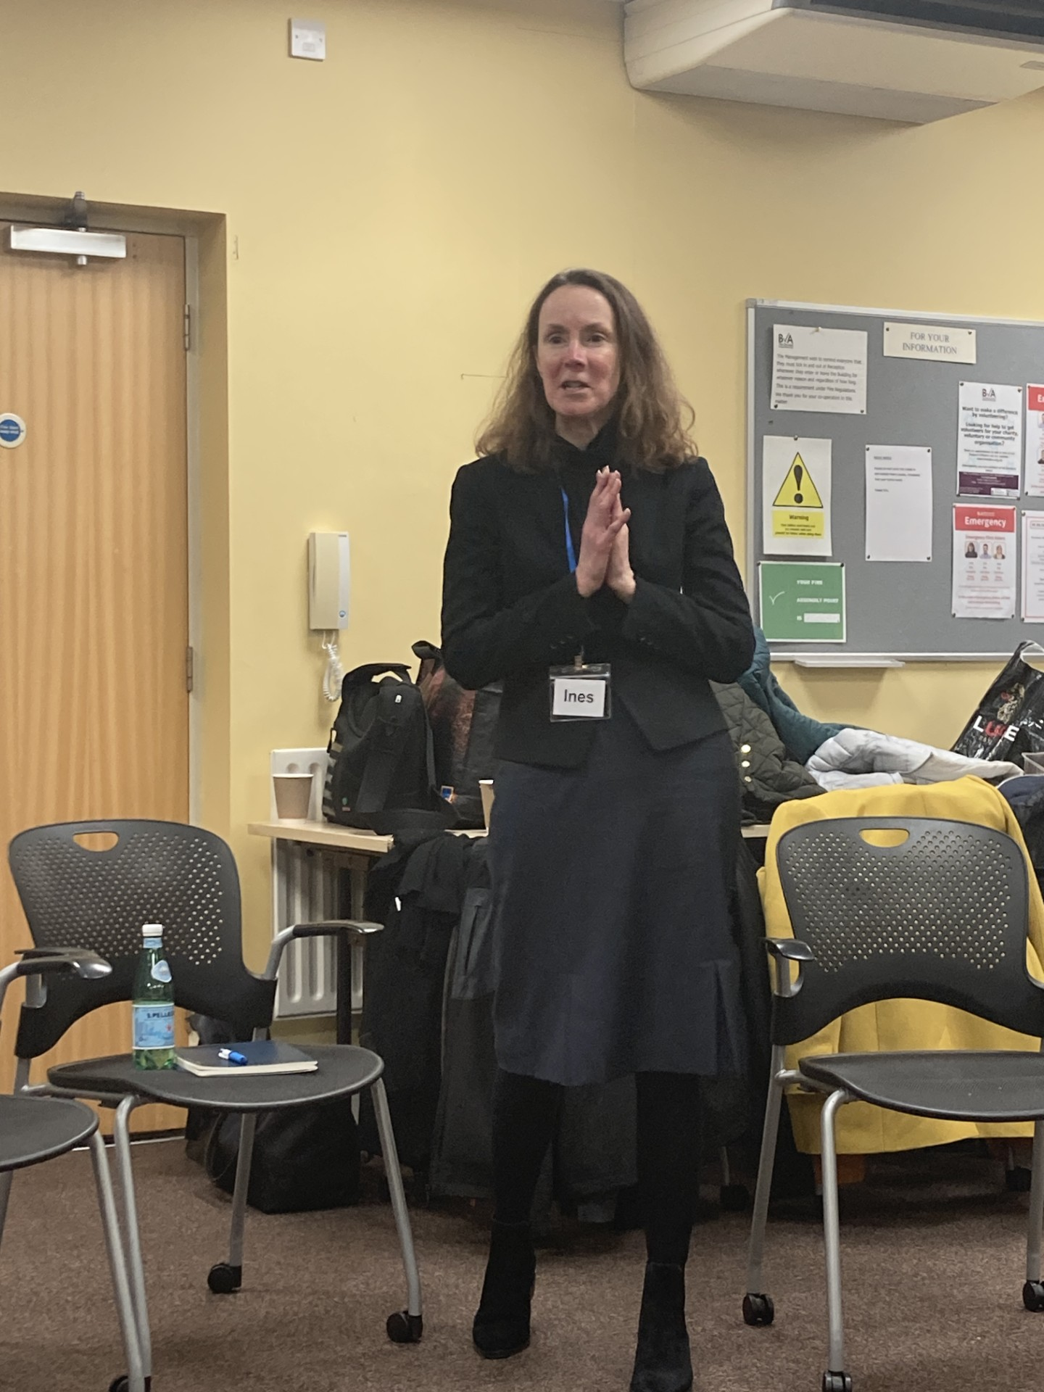
Ines Canella-Jager of Tinnitus UK speaking at the Christmas party

List of 2025 meetings

All the dates for all meetings in 2025 both in-person and on-line are below. These are all Wednesdays with a 7.30 pm start. All the in-person meetings will be at the Orchard, Basingstoke Voluntary Action, White Hart Lane, Basingstoke RG21 4AF. Please make a note of these in your 2025 diary.
15 January 2025 Zoom with AGM | 16 July On-line Share and Care
12 February 2025 In-person The Orchard | No August meeting
19 March 2025 On-line Share and Care | 10 September 2025 In-person The Orchard
23 April 2025 In-person The Orchard | 15 October 2025 On line Share and Care
14 May 2025 On-line Share and Care | 12 November 2025 In-person The Orchard
18 June 2025 In-person The Orchard | 10 December 2025 Christmas Party

We remain very interested to hear members views on what they would like to see from the Tinnitus Support Group and the preferences for in-person or on-line meetings. Just drop us an email when you have a minute. All contributions are very welcome. Your committee is very keen to provide what the members want.

In practice, at some point early in 2025 we will switch from Zoom to Microsoft Teams for our on-line meetings. This is because Zoom has become so expensive, and Teams is much better value for money.

That’s all from us for now. Best wishes, Peter Humphreys, on behalf of the Committee.

Our aim is to keep membership and participation in the Group free. You can help by considering making a voluntary donation no matter how small, to the Group. The name of our bank account is “Basingstoke and Area Tinnitus Support Group.” The sort code is 60-02-49. The account number is 80235956. It would be helpful if you put your name as the reference, but not essential, if you prefer to donate anonymously.

